SIMATS ENGINEERING
ASSESSMENT TOOL 1: Experiments

COURSE NAME: | Cloud Computing and Big Data Analytics | COURSE CODE: | CSA1596

COURSE OUTCOME COVERED
CO3: Implement cloud-based solutions using cloud storage, web APIs, and platform services for real-world applications. (BL3)
Assessment Tool Weightage: 40%

Dave's Taxonomy: Precision (Level 3)  Question Count: 5 | Total Marks: 40
Duration : 60 Minutes
Code of Conduct
I ____________________ (Name / Reg No) certify that this submission is my original work and that I have adhered to the guidelines specified for this assessment.
I understand that any violation of academic integrity rules will result in disciplinary action.
Signature of the student: ____________________

Experiments Rubric
Criteria | Weightage | Level 4 - Exemplary | Level 3 - Proficient | Level 2 - Developing | Level 1 - Beginning
Experimental Design | 25% | Design is systematic and technically strong | Mostly correct design | Basic design with gaps | Poorly designed activity
Use of Tools / Platforms | 20% | Appropriate and effective use of cloud tools | Good tool usage with minor issues | Limited tool usage | Incorrect or missing tool usage
Application of Concepts | 20% | Concepts are applied accurately to practical tasks | Mostly accurate application | Partial application | Weak application
Analysis and Output | 20% | Strong analysis and meaningful outcome interpretation | Good analysis with minor gaps | Basic analysis | Little or no analysis
Documentation | 15% | Clear, structured, and complete documentation | Mostly complete documentation | Partially complete | Poor documentation

Total Marks Awarded:

Assessment Tasks-I
Experiments

Experiment 1: Create a simple cloud software application for Library book reservation system for SIMATS library using any Cloud Service Provider to demonstrate SaaS include the necessary fields such as Title of the book, author, publications, Year, edition, no of copies, Rack no, status (taken/returned) etc.

Experiment 2: Create a simple cloud software application for Payroll Processing System using any Cloud Service Provider to demonstrate SaaS include the necessary fields such as Name of the employee, experience in present org , over all experience, basic pay, HRA, DA, TA, net pay, gross pay etc.
Experiment 3: Demonstrate virtualization by Installing Type-2 Hypervisor in your device, create and configure VM image with a Host Operating system (Either Windows/Linux). Create a Virtual Machine with 1 CPU, 2GB RAM and 15GB storage disk using a Type 2 Virtualization Software.

Experiment 4: Demonstrate virtualization by Installing Type-2 Hypervisor in your device, create and configure VM image with a Host Operating system (Either Windows/Linux). Create a Cloning of a VM and Test it by loading the Previous Version/Cloned VM

EXPERIMENT -1
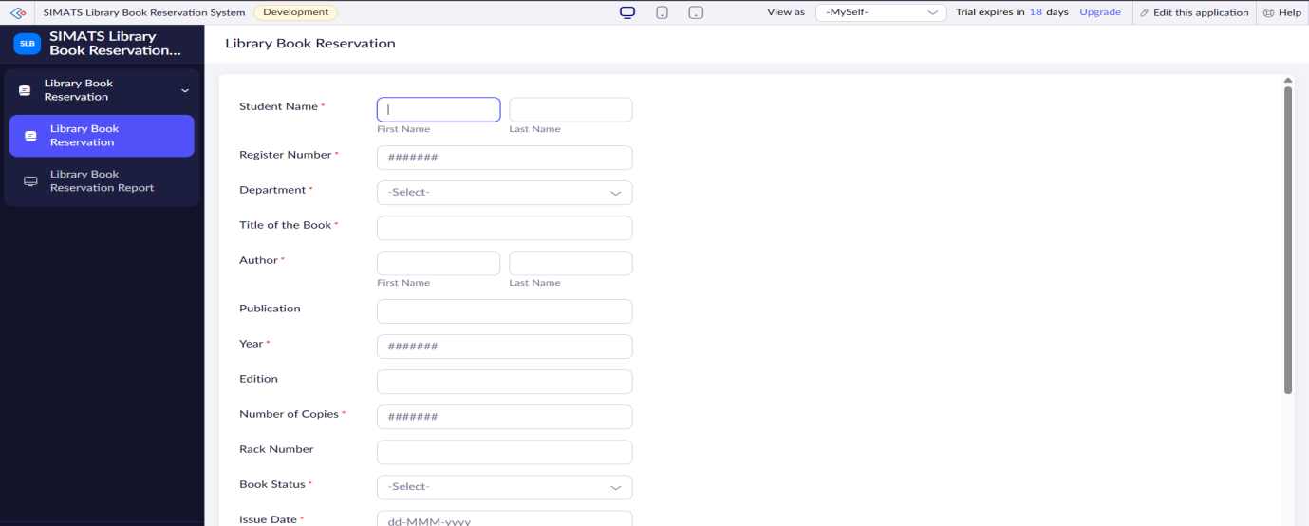

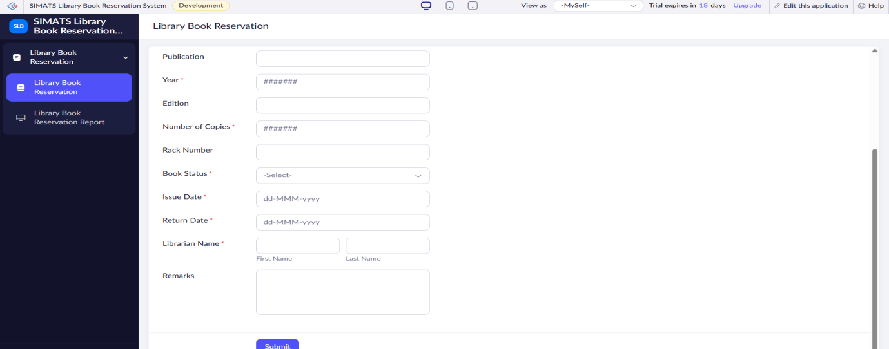

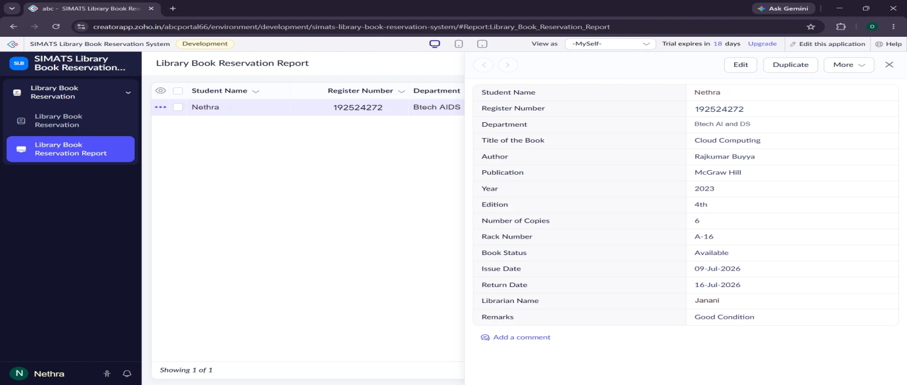
EXPERIMENT-2
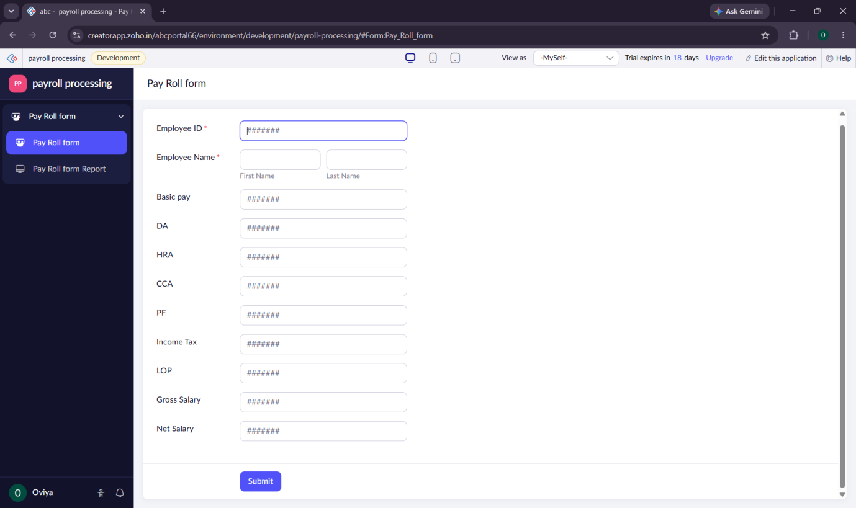
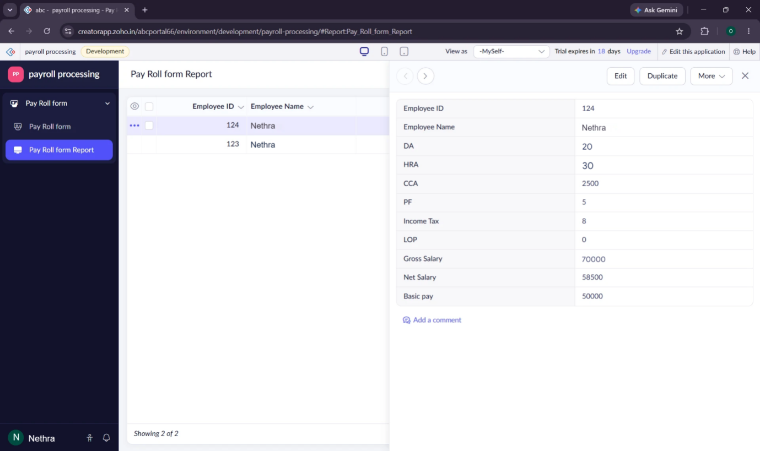

EXPERIMENT – 3
Create a Virtual Machine with 1 CPU, 2GB RAM and 15GB storage disk using a Type 2 Virtualization Software.
Aim:
To create a VM with:
- No of processor : 1
- Memory : 2 GB
- Hard disk : 15 GB
Steps:
- Download VMware software and install it as Type-2 Hypervisor.
- Download Ubuntu or tiny os as ISO image file.
- In VMware workstation Create new VM
- Do the configuration based on given conditions.
- Created a virtual Machine .
- Launch the VM.
Implementation:
Download and open VMware software.
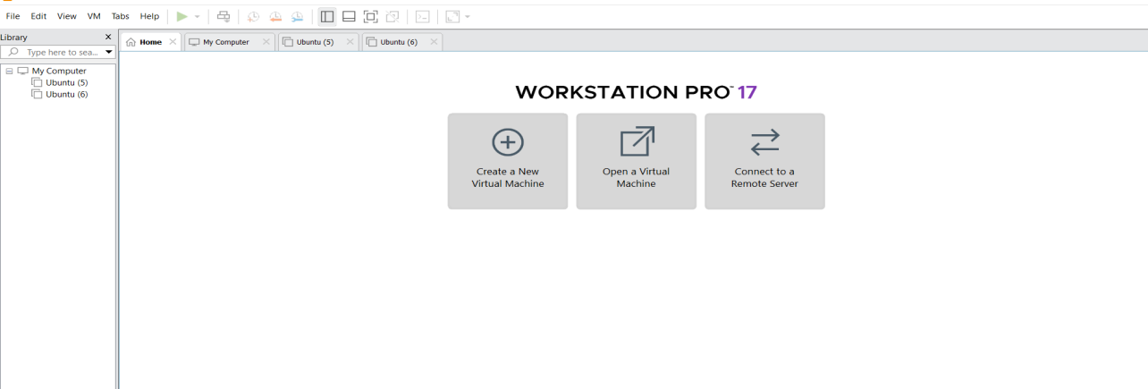

2.Create a new VM



Name it anythingclick on nextAdjust the size of disk change the option to first and then click on next.
 Click on Finish to Launch .
3.VM is created


4. we can customize the configuration of hard disk while crearing VM and can add additional hard disk later if needed

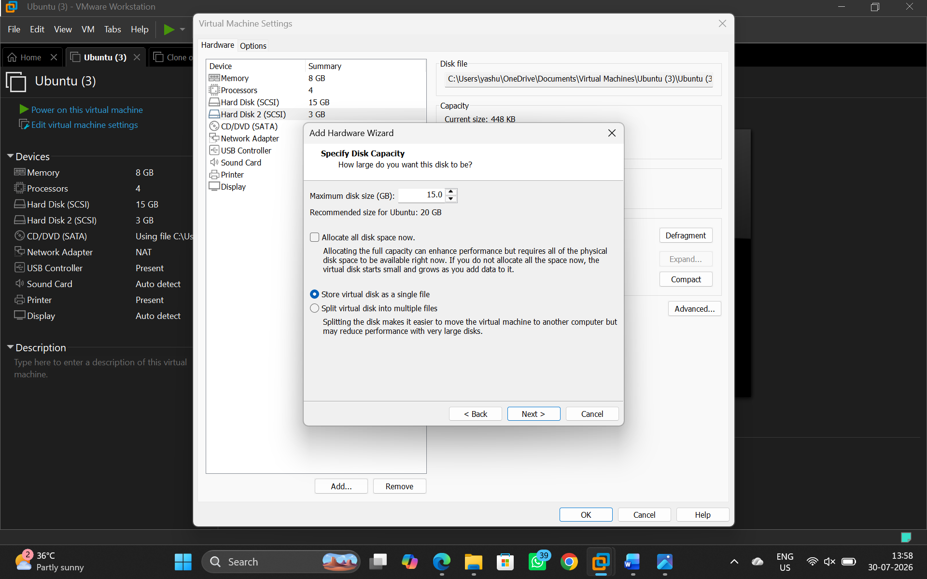
5.Double click on the processor and set it to given configuration
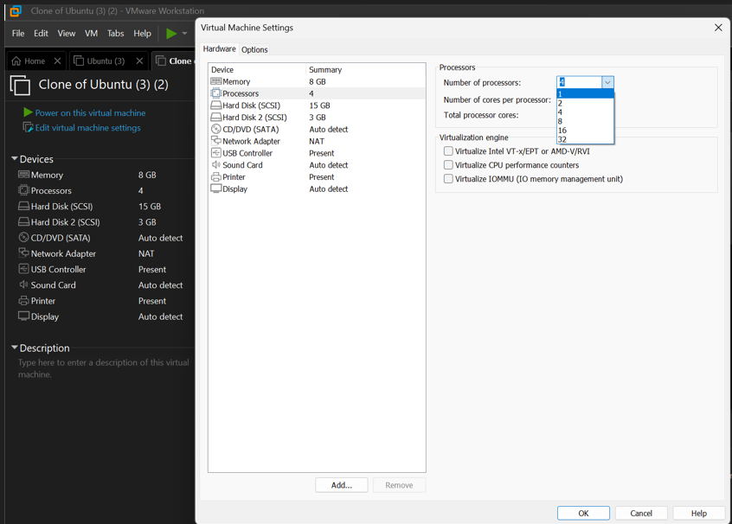

7.Double click on the ram to customize the desired storage
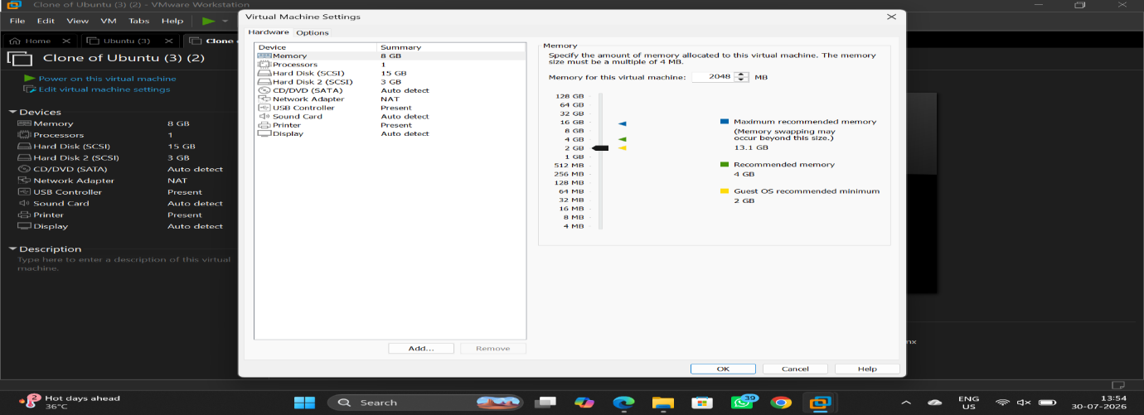

8.VM with given configuration
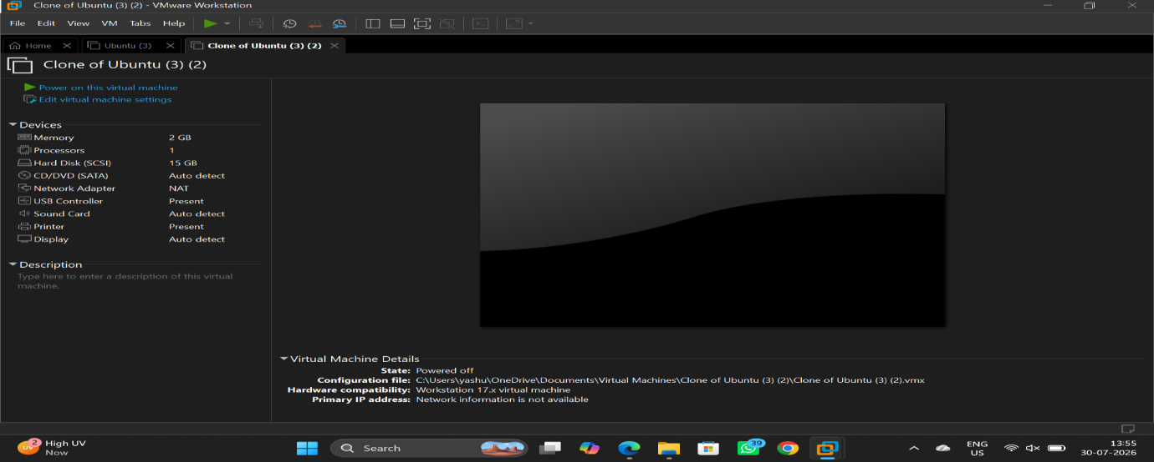

EXPERIMENT-5

Create a Cloning of a VM and Test it by loading the Previous
Version/Cloned VM
Aim:
To Create a Cloning of a VM and Test it by loading the Previous
Version/Cloned VM.
Steps:
- Download VMware software and install it as Type-2 Hypervisor.
- Download Ubuntu or tiny os as ISO image file.
- In VMware workstation Create new VM
- Do the configuration based on given conditions.
- Create VM
- Go to VM ManageClone.
- Launch the VM.
Implementation:
- Download and open VMware software.
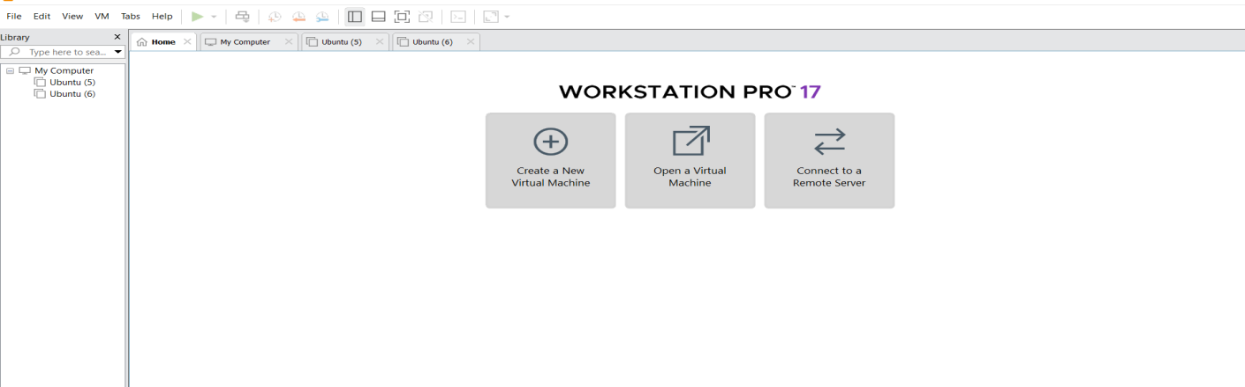
2.Create a new VM

Name it anythingclick on nextAdjust the size of disk change the option to first and then click on next.
Click on Finish to Launch .
3.VM is created
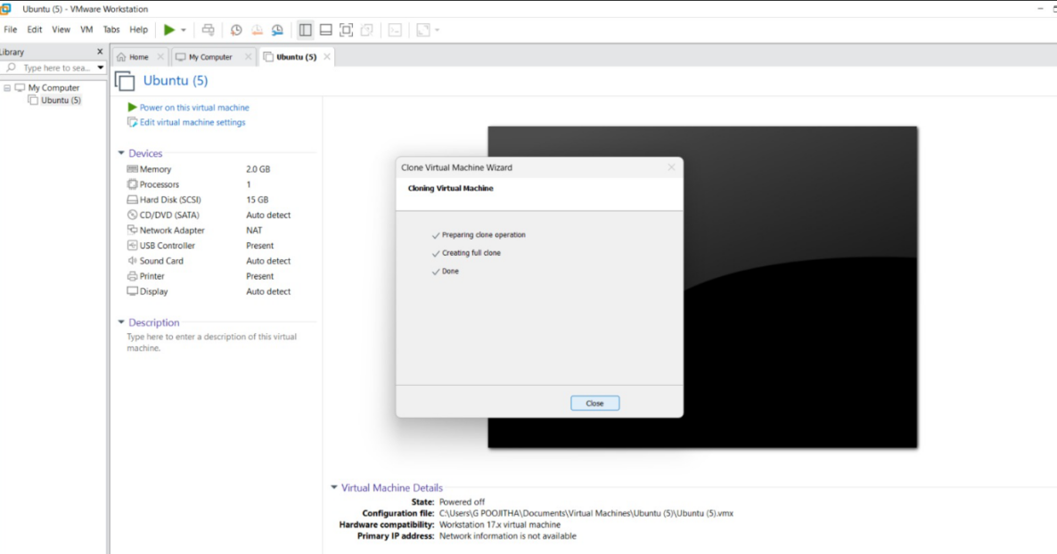
4. Create Clone
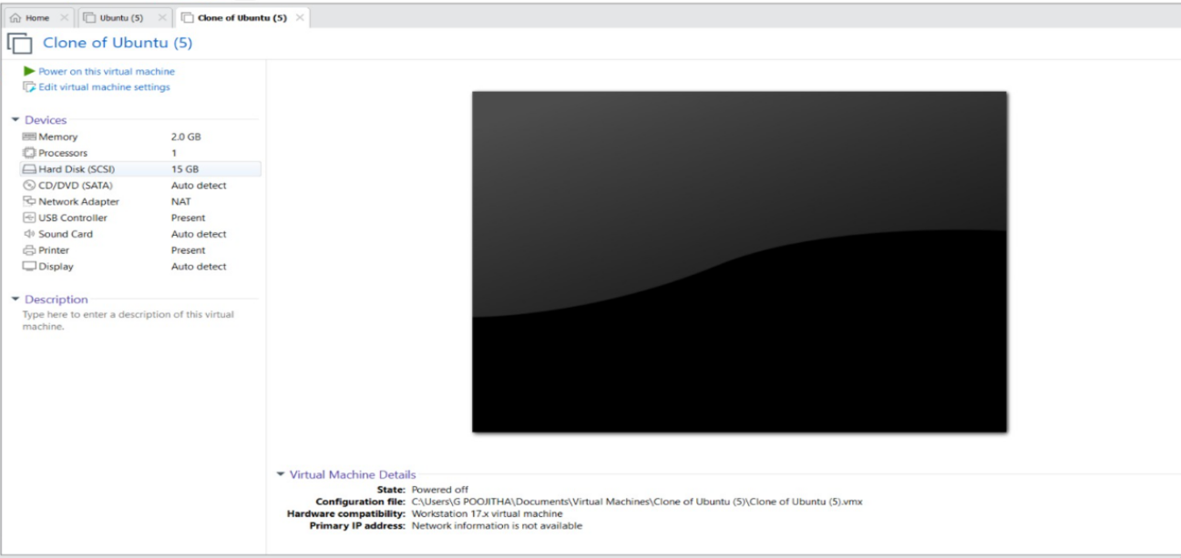
Fig : SSClone has Created and it has same properties as before VM.

